**PROJECT DESIGN PHASE-II**

**DATAFLOW DIAGRAM**

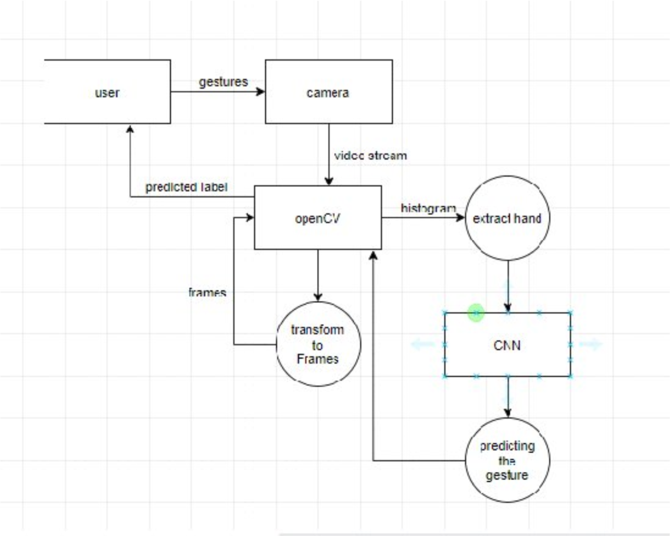

|  |  |
| --- | --- |
| Date | 03-11-2022 |
| Team ID | PNT2022TMID41786 |
| Project Name | Real Time communication system  powered by AI for Specially Abled |
| Maximum Marks | 4 Marks |

**Data Flow Diagrams:**

A Data Flow Diagram (DFD) is a traditional visual representation of the information flows within a system. A neat and clear DFD can depict the rightamount of the system requirement graphically. It shows how data enters and leaves the system, what changes the information, and where data is stored.

**EXAMPLE-1:**

***EXAMPLE-2:***

